Jordan Geltner -jmg920
Project A: What did Particle A say to Particle B? Flock Off
User's Guide:
The arrow keys can be used to navigate parallel to the XY-ground plane. The pageUP and pageDown keys give you leeway in the Z-axis, allowing you to move up and down. Home and end help you pan left and right, while right control and right alt let you pan up and down. Pressing the s key cycles through a few different solvers: the ad hoc solver, euler's, midpoint, and Verlet. Pressing the g key can toggle gravity. If you time it well, some fun stuff will happen. Pressing the f key turns flocking on or off, producing a system of 50 particles that will avoid each other. The h key prints out the help menu, which will return all this informaiton again. Pressing r will reset the scene to a new set of particles.
Code Guide:
This code has been taken from J. Tumblin's GlutBallD file for his Computer Graphics course. It has been modified to dynamically allocate particles, forces, and constraints. There are no more hard-coded state-spaces here. The main changes that have been added are the implementation of the Verlet method, usage of the midpoint method, a few windy forcefields, and some useful UI stuff. Additionally, all the camera movement code has been imported from previous work by this report's author.
Camera Code:
case GLUT_KEY_LEFT: // left arrow key
cout << "left-arrow key.\n";
cameraX -= 1;
lookAtX -= 1;
break;

This small sample of the camera code is representative of the entire suite: there is a switch statement with a case for each different key. Underneath these cases, a global variable holding the camera's current position and its target can be modified to move the camera around the scene.
Verlet Integration:

case NU_SOLV_VERLET:
stateVecAplusBtimesC(pS1,pS0,pS0dot,timeStep);
for(int i = 0; i < partCount; i++)
{
float magnitude = sqrt(pS1[i].xvel*pS1[i].xvel +
pS1[i].yvel*pS1[i].yvel +
pS1[i].zvel*pS1[i].zvel);
pS1[i].xvel +=pS0dot[i].xvel/magnitude;
pS1[i].yvel +=pS0dot[i].yvel/magnitude;
pS1[i].zvel +=pS0dot[i].zvel/magnitude;
}
break;

This implementation of the Verlet Integration method simply computes the change in the state space from one time step, then modifies the new velocity based upon the magnitude of the velocity for the change in state space. I don't think its any more accurate than Euler's although it does produce very distinct results.
Flocking:
for (i=0; i<partCount; i++)
{
for (int k=0; k<partCount; k++)
{
int xdiff = pS[i].xpos - pS[k].xpos;
int ydiff = pS[i].ypos - pS[k].ypos;
int zdiff = pS[i].zpos - pS[k].zpos;
if(abs(xdiff) < .5 && abs(ydiff) < .5 && abs(zdiff) < .5 &&
abs(xdiff) != 0 && abs(ydiff) != 0 && abs(zdiff) != 0)
{
pS[i].xftot+=mag*xdiff;
pS[k].xftot-=mag*xdiff;

pS[i].yftot+=mag*ydiff;
pS[k].yftot-=mag*ydiff;

pS[i].zftot+=mag*zdiff;
pS[k].zftot+=mag*zdiff;
}
}
}

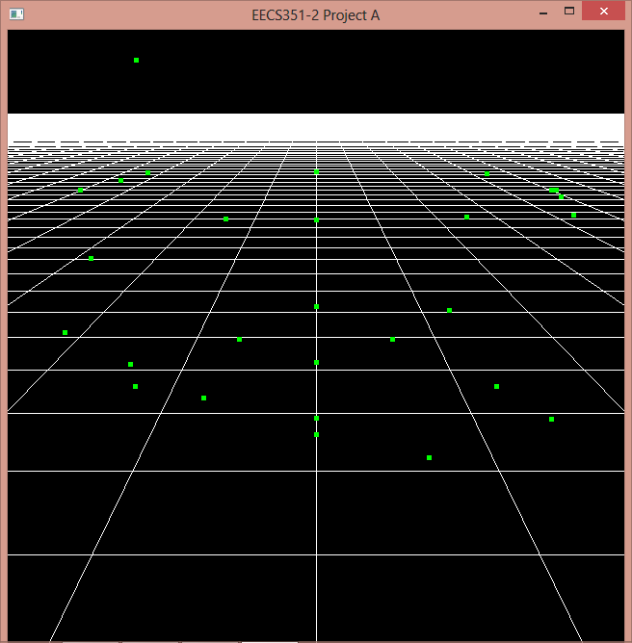
This code lies within the applyAllForces function as a method of creating a simple repulsive force amongst all particles. It is obvious that the number of calculations here soon becomes inconceivable once you have a couple 100 particles, so I have to change the particle numbers down when I use this force. Basically, if the distance between two particles is less than half a centimeter, they immediately move the opposite direction as their contact normal. This makes all the particles avoid each other.
Windy Box:
for(i=0; i < partCount; i++)
{
mag = pS[i].mass;
if (pS[i].xpos < -5)
pS[i].xftot += mag * 1;
else if (pS[i].xpos > 5)
pS[i].xftot -= mag * 1;

if (pS[i].ypos < -5)
pS[i].yftot += mag * 1;
else if (pS[i].ypos > 10)
pS[i].yftot -= mag * 1;

if (pS[i].zpos < -5)
pS[i].zftot += mag * 1;
else if (pS[i].zpos > 5)
pS[i].zftot -= mag * 1;
}

I call this my windy box because if the particles are left alone (i.e. Gravity turned off), they will group into a box-shape and eventually come to rest (if there is damping). This can be seen in the following picture:
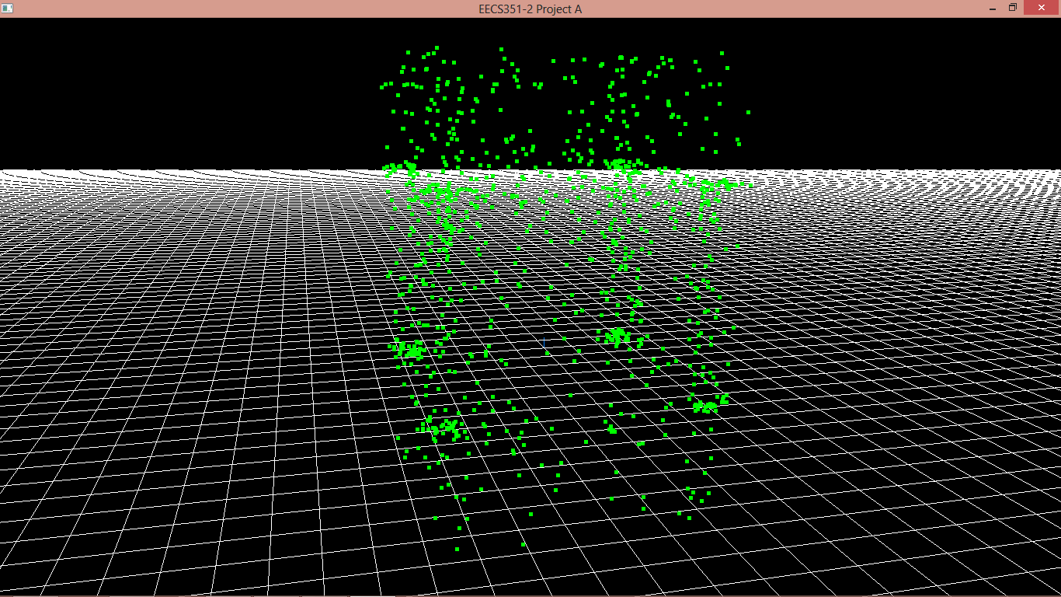
Another less visible forcefield is a windy sphere around the origin:
Origin Sphere:

for(i=0; i < partCount; i++)
{
mag = pS[i].mass;
double x = pS[i].xpos;
double y = pS[i].ypos;
double z = pS[i].zpos;

double distance = sqrt(z*z + x*x + y*y);
if(distance <= 5)
{
pS[i].xftot += mag * x/distance; //should be unitized
pS[i].yftot += mag * y/distance; //should be unitized
pS[i].zftot += mag * z/distance; //should be unitized
}
}

This code checks the distance of each particle from the origin, and then applies a force if it is too close. Combined with the windy box, this makes the particles in a box with curved inner corners around the origin.

Initialization:
for (i = 0; i < partCount; i++)
{
pS0[i].xpos = (rand() % partCount - partCount/2)/8;
pS0[i].ypos = (rand() % partCount - partCount/2)/8;
pS0[i].zpos = (rand() % partCount – partCount/2)/8;
}

This code initializes all the particles to have random positions (within a reasonable range of the origin). I put this in just because it was too boring to put all the particles at the same spot and too much work to individually code the position of each particle. That would also be stupid as they are dynamically allocated and the size can very.

